Doc. Name | SOFTWERE REQUIREMENT SPECIFICATION
Project Title | Hospital Recommendation System
Doc. No. | 1 | Team | KOCHI
 |  | 4

Functional designation of approving authority | Project Guide Name:  Shobana Devi | Functional designation of issuing authority | Project Leader  Name: Saikumar Pedige
For any clarifications/corrections/amendments in this document please contact issuing authority

Issue History
Issue | Rev. | Effective | Reason for Re-issue | Total Doc. | Date of
No. | No. | From(Date) |  | Pages | consolidation
 |  |  |  |  | of review
 |  |  |  |  | outputs
1 | 00 |  | First issue

Team member details
PNR | Participant Name | Email-Id | Phone
220360520043 | SAIKUMAR PADIGE | saikumarpadige9@gmail.com | +91-98346 24813
220360520046 | SAURABH KULKARNI | saurabhkulkarni654@gmail.com | +91-77760 84847
220360520018 | HANUMANT BORADE | hanumantborade@gmail.com | +91-95278 58293
220360520057 | VIPUL PATIL | vipulpatil257@gmail.com | +91-77982 00730
220360520026 | LALNA BARHATE | lalubarhate18@gmail.com | +91-70660 95630
220360520041 | SACHIN WARHADE | Warhade.sachin09@gmail.com | +91-9130842056

Approved By:
(Functional designation) Date of approval: _ _ / _ _/ _ _ _ _

Notes:
* Mark control status as “Controlled Copy if read from version control system” in document maintained as softcopy.
** “Copy No” field needs to be filled only when hard copies of the document are distributed as controlled copies. In such cases, mark control status as “Controlled” and Copy No as serial numerals: ex: 1, 2, 3 etc.
Copyright
No part of this document may be reproduced in any form without the prior permission in writing of issuing authority
Contents
1. Introduction 2
1.1 Name of the product 2
1.2 Definitions 2
1.3 Reference 2
2. General Description 3
2.1 Product Perspective 3
2.2 Product Functions 3
2.3 Operating Environment Error! Bookmark not defined.
2.4 User Characteristics and classes 3
2.5 Assumptions and dependencies 4
3. Specific Requirements 5
3.1 Functional Requirements 7
3.1.1 Functional Requirement 7
3.1.1.1 Introduction Input, Process and Output 7
3.1.1.2 Use case and UML diagram 23
3.2 External Interface Requirements 29
3.2.1 User Interfaces 29
3.2.2 Hardware interfaces 29
3.3 Non-Functional Requirements 30
3.4 Other Requirement 33
3.4.1 Technical Requirement 33
3.4.2 Database 33

Introduction

This document explains the system requirements and scope for developing Connect To Care. The system will be used as the application that suggests hospitals, clinic, dispensaries or other health institution based on the patient’s illness and patient feedbacks. Objective of the system is to suggest a better hospital in terms of treatment, cost effective and satisfactory index.
Patients can search and book doctor’s appointments easily based on their location, availability, and specialty. Also, hospitals can manage their doctor's and patients’ records.
Connect To Care - Hospital Recommendation System could divide into the three main parts, Patient part, Doctor part and Admin part. This document describes the system requirements.

Name of the product
Connect To Care – Hospital Recommendation System

Definitions
NIL

Reference
www.google.com
www.w3school.com
www.wikipedia.com
IEEE. IEEE STD 830-1998 IEEE Recommended Practice for Software Requirements Specifications. IEEE Computer Society, 1998.

General Description

Product Perspective

This Connect To Care web application is a self-contained system that manages activities of the Hospitals, Doctors, Patient Information and various others factors are also involved in order to manage the system. Also, this Hospital Management System recommend the hospital and doctor to patient as per patient need or requirement.

Product Functions
Connect To Care mainly supports the following high-level functions,
- Search: Patient can search hospital on based of their location.
- Book Appointment: Patient will be able to book doctor’s appointment.
- Health Timeline: System allows doctors to add and update the particular patient health timeline which consist of symptoms and advice from doctor and patient will be able to only see that health timeline.
- Chat Bot: User can chat with our system bot by providing some basic details. On the basis of that our chat bot will suggest the best hospital and doctor available at their location and they can book appointment from their also.
- Also, there are various functionalities that are describe in the functional requirement section.

Operating Environment

- Windows 7 or above version with web browser like Google Chrome, Firefox, Microsoft edge, safari
- Stable internet connection required – minimum 1 mbps
- Minimum system RAM – 2GB
- Minimum Processor – i3 and above

User Classes and Characteristics

The System will be used in hospital. The doctors and the patient will be the main users. Given the condition that not all the users are computer-literate. Some users may have to be trained on using the system. The system is also designed to be user- friendly. It uses a Graphical User Interface (GUI).
Patient: These are the users or people who will use the services provided by the hospital.
Doctors: These are the users or peoples who are professional associate with hospital and provide the services.
Hospital: These are the various entities which provide the various hospital services.
Admin: They are responsible for managing the Connect To Care complete system and database.

Assumptions and dependencies

• It is assumed that the Hospital will have enough trained staff to take care of the system.
• It is assumed that computers will be available at hospital before the system is installed and tested.
• It is assumed that patient should know basic knowledge to use computer.

Specific Requirements

Functional Requirements

SR. NO. | MODULE NAME | APPLICABLE ROLE | DESCRIPTION
1. | Login | Admin  Hospital  Doctor  Patient | Admin: Can login and manage the status of Hospital.  Hospital: Can login using unique Id and Password after this system shall show a profile with links to maintain the Hospital and Hospital Data.  DOCTOR: Can login using unique Id and Password after this system shall show his/her profile.  PATIENT: Can login using unique Id and Password after this system shall show his/her profile.
2. | Registration | Hospital  Patient | Hospital: Can Register by filling all the required details, after this the system will verify the details and check if already registered or not.  PATIENT: Can Register by filling all the required details, after this the system will verify the details and check  if already registered or not.
3. | Book Appointment | Patient | PATIENT: Can Select doctor, date time and make an appointment request after this system shall show a confirmation for appointment request.
4. | Cancel Appointment | Patient Doctor | PATIENT: Can Cancel appointment if want to by just one click after this system shall ask for re-schedule.  DOCTOR: Can Cancel appointment if want to by just one click after this system shall send a message to the patient.
5. | Edit Profile | Hospital Doctors Patient | HOSPITAL: Can edit their profile data with verification whenever they want.  DOCTORS: Can edit their profile data with verification whenever they want.  PATIENT: Can edit their basic details whenever they want.
6. | Health Timeline | Doctor Patient | DOCTOR: can add and update health details of patient and can give advice to patient.  PATIENT: can only view the health timeline given by doctor.
7. | Prescription | Doctor Patient | DOCTOR: can add and update prescription to a particular patient.  PATIENT: can only view and download the particular prescription given by doctor.
8. | Appointment Slots | Doctor | DOCTOR: can create and remove available slots for booking the appointment based on his availability.
9. | Hospital Module | Hospital | Hospital: Can add a new doctor by filling all the details after this system shall show a confirmation message. Can Remove a doctor by just one click after this system shall show confirmation message
10. | Patient Module | Patient | PATIENT: can search for the hospital in that he can see particular department doctor and book appointment.  Can also change the password.  Can also add, delete and update personal details like age, blood group, etc.

Functional Requirement

Introduction
Above 3.1 are the functional requirement which has to be develop and for that below inputs, process and expected output are explain in detailed.

- Admin Module:
Input: Login Credential like username and password.
Processing / Conditioning: To Access the complete system authentication of admin needed to check with login credential and database and also can manage the status for new enrolled and existing hospital.
Output: Admin can manage the status for new enrolled and existing hospital. Also, admin can view all the hospital, doctors and patients’ data.

  - Hospital Module:
- Hospital should be responsible for following activities.

Hospital Registration
Input:
- Hospital Recommendation System compels to create the account for Hospital. So, the system should provide the function which makes admin to create new account.
- When Hospital creates new account, the function demands information described as below.
  - Login information
  - Contact Details

- Login information
The Login information consists of some items described as below
  - HID Auto – Generated
  - Hospital Name
  - Password
  - E-mail address
*All items are compulsory demanded.

Email
The Email should be unique. If the email corresponds with not case-sensitive to other which is previously registered, the email should not be registered as an account.

Password
The Password has constraints which makes the Password consists of more than or equal 8 and less than or equal 16 characteristics including characters including described as below.
- Numeric figure (at least one)
- Capital alphabet (A-Z) (at least one)
- Small alphabet (a-z) (at least one)
- Special character (#, $, %, &, etc.) (at least one)

- The password is masked by dummy characters. The re-entering Password is demanded.
- The password must be encrypted in Hospital Recommendation System.

- Contact Details
- The Contact Detail consists of some items described as below
  - Area
  - City
  - State
  - Contact Number
- All items are compulsory demanded.
  - Address
    - Address should be filled.
    - The city and state should be selected from options.
Processing / Conditioning:

Login Process
- Hospital Recommendation System always compels hospital authentication before using itself except when a new account is successfully created.
- The Hospital authentication demands Username and Password. The Username and the Password should be checked as –
The Username and the Password should be existed and correct.
- If The Email and the Password are not equal to what the admin has registered, the admin authentication cannot be provided.

Output:
    - Hospital admin get log in and able to see following options:

- The “Hospital Home Page” provides some items described as below.
  - A button to logout
  - A button to add new doctor
  - A button to view patient list
  - A button to view doctor list
  - A button to hospital records
  - A button to add new patient
  - A button to manage accounts (can enable or disable the account for the particular time or permanently)

Add Doctor (Registration)
  - Admin can create the new account for doctor by verifying all the information given by the doctor via email.
  - When admin creates new account, the function demands information described as below.
Input: The details information consists of some items described as below
  - First Name
  - Last Name
  - Email
  - Area
  - City
  - State
  - Date of Birth
  - Gender
  - Username
  - Contact Number
  - Languages known
  - Qualification
  - Specialization
*All items are compulsory demanded.
Processing / Conditioning:
- Admin will verify all the details and create the account for doctor.
- Admin will send first login credentials to doctor (email and password).
- Password sent by admin is in the form firstname@123.
Output: Doctors account created successfully.

- View Patient List
  - Admin should be able to see all the patient list according following criteria:
    - All registered patients
    - Location wise
    - Doctor wise
    - According to appointment date

- View Doctor List
- Admin should be able to see all the doctor list according following criteria:

  - All registered doctors
  - Location wise
- According to registration date of doctor

- Account Management
  - Admin should able to manage all the accounts (doctors) with following activities,

- Enable accounts
- Disable accounts (Admin can disable account for temporary or permanently if the community guidelines are not followed by doctor)

  - Doctor Module
Input:
Username and password provided by Hospital Admin.
Processing / Conditioning:

Login Process
  - Hospital Recommendation System always compels doctor authentication for using web application.
  - The doctor authentication demands Email and Password. The Email and the Password should be checked in two ways.
- The Email and the Password should be existed and correct.

If The Email and the Password are not equal to what the user has registered, the doctor authentication cannot be provided.
If The Email and the Password are equal to what the user has registered, the doctor authentication be provided.
Output:
Doctor able to see following options as doctors gets log in and able to work following functions
  - The “Doctor Home Page” provides some items described as below:
    - A button to logout
    - A button to Reset Password
    - A button to Active Appointments
    - A button to Create and remove slots
    - A button to Update profile
    - A button to Cancel Appointments
    - A button to View Appointments History
    - A button to Show todays slots
    - A button to search for patient

Forgot Password Process
- When doctor lost their Password, the recovery method should be provided by Hospital Recommendation System.

The recovery method is described below:
  - First, doctor enters their Email for Hospital Recommendation System
  - Next, Hospital Recommendation System will send OTP on the registered email.
  - Only when the Answer is correct, doctor can set the new password by E-mail which also has been registered since when the Account was created.
  - Only when OTP entered is match then doctor will able to change password.
  - The new password is manually entered by doctor.
  - Of course, the new password should consist of more than or equal 8 and less than or equal 16 characteristics including at least a numeric figure, a capital alphabet, a small alphabet, and a special character.

- Change Password Process
- When doctor wants to change their Password, the measure should be provided by Hospital Recommendation System.
- Therefore, system should provide the function which is available after getting the doctor authentication.
- The function demands the current password and the new password.
  - Of course, the new password should consist of more than or equal 8 and less than or equal 16 characteristics including at least a numeric figure, a capital alphabet, a small alphabet, and a special character.
  - The current password and the new password are masked by using dummy characters.
  - The new password is demanded to enter twice to avoid a typing error.

- Only when the current password is correct, doctor could change their Password
- When the current password is changed into new password, system compels doctor authentication again.

Active Appointments Process

- Doctor can able to see all the active appointment for a day.

- Create Slot Process
  - Doctor can create slots according to the availability.
  - Doctor has to provide following details to create slots.
    - Start Date
    - End Date
    - Start Time
    - End Time
    - Slot duration in minutes
    - Break time
    - Holidays
- All items are compulsory demanded.

- Update Profile Process
  - Hospital Recommendation System should provide the function which makes the account updated for doctor.
  - The information Doctor could update is described below:
    - Contact Number
    - Area
    - City
    - State
    - Languages
    - Qualification
    - Specialization
*All items are compulsory demanded, but updating is optional.

- Cancel Appointment
- Doctor can cancel particular appointment if required.

- View Appointment History
- Doctor can view all appointments history.

- View Todays Slots
- Doctor can view all the slots which are available for booking appointments.
- Forget Password Process
- Login Process
- View Todays Slots

Input:
Processing / Conditioning:
Output:

  - Patient Module
  - Patient is the user of system who can check hospital according to location and can check doctor based on specialization.
  - He is also able to book the appointment of available doctor.
Input:
- Registration Process
  - Hospital Recommendation System compels to create the account for appointment booking. So, the system should provide the function which makes Patients create new account.
  - When Patient creates new account, the function demands information described as below.
    - Login information
    - Contact Details
  - Login information
The Login information consists of some items described as below
    - PID Auto – Generated
    - User Name
    - Password
    - First Name
    - Last Name
    - E-mail address
    - Date of Birth
    - Gender
    - Blood Group

*All items are compulsory demanded.

Email
The Email should be unique. If the email corresponds with not case-sensitive to other which is previously registered, the email should not be registered as an account.

Password
The Password has constraints which makes the Password consists of more than or equal 8 and less than or equal 16 characteristics including characters including described as below.
- Numeric figure (at least one)
- Capital alphabet (A-Z) (at least one)
- Small alphabet (a-z) (at least one)
- Special character (#, $, %, &, etc.) (at least one)

- The password is masked by dummy characters. The re-entering Password is demanded.
- The password must be encrypted in Hospital Recommendation System.

  - Contact Details
The Contact Detail consists of some items described as below
    - Area
    - City
    - State
    - Contact Number
*All items are compulsory demanded.

- Address
  - Address should be filled.
  - The city and state should be selected from options.

Processing / Conditioning:
- Login Process
  - Hospital Recommendation System always compels user authentication for using web application.
  - The user authentication demands Email and Password. The Email and the Password should be checked in two ways.
- The Email and the Password should be existed and correct.

If The Email and the Password are not equal to what the user has registered, the user authentication cannot be provided.
If The Email and the Password are equal to what the user has registered, the user authentication be provided.
Output:
The “Patient Home Page” provides some items described as below.
  - A button to logout
  - A button to update Account
  - A button to Change Password
  - A button to Search Hospital
  - A button to Book Appointment
  - A button to Cancel Appointment
  - A button to View Appointment
  - A button to view Health Timeline
  - A button to view prescription

- Forget Password Process
- When system user lost their Password, the recovery method should be provided by Hospital Recommendation System.
The recovery method is described as below:
  - First, system user enters their Email for Hospital Recommendation System.
  - Next, Hospital Recommendation System will send OTP on the registered email.
  - Only when the Answer is correct, user can set the new password by E-mail which also has been registered since when the Account was created.
  - Only when OTP entered is match then user will able to change password.
  - The new password is manually entered by patient.
  - Of course, the new password should consist of more than or equal 8 and less than or equal 16 characteristics including at least a numeric figure, a capital alphabet, a small alphabet, and a special character.

- Change Password Process
- When patient wants to change their Password, the measure should be provided by Hospital Recommendation System.
- Therefore, system should provide the function which is available after getting the patient authentication.
- The function demands the current password and the new password.
  - Of course, the new password should consist of more than or equal 8 and less than or equal 16 characteristics including at least a numeric figure, a capital alphabet, a small alphabet, and a special character.
  - The current password and the new password are masked by using dummy characters.
  - The new password is demanded to enter twice to avoid a typing error.

- Only when the current password is correct, patient could change their Password
- When the current password is changed into new password, system compels user authentication again.

- Update Profile Process
  - Hospital Recommendation System should provide the function which makes the account updated for patient.
  - The patient can update the information as described below
    - User information

  - The User information:
The updatable items as described below.
    - Contact Number
    - Area
    - City
    - State
All items are compulsory demanded, but updating is optional.
- Search Hospital
After login user can search for a hospital based on
  - Location
  - Specialization
If user select location as a criterion, then the list of all hospitals of respective location will get displayed.
If user will search for the hospital without selecting the criteria (location or specialization) or user select specialization as a criterion without selecting the location, then system will give the message that user must select location to get list of hospital.
And after that patient can book appointment.

- Book Appointment
After getting the list of doctors according to location and specialization patient can select the particular doctor.
After selecting the doctor, all the slots will be shown to the patient. The slots before the login time of patient and slots which are already booked will not be shown to patient. Patient can see only the slots which are available for booking.
Patient can book appointment according to the available slots of the respective doctor.
- Cancel Appointment
After successfully booking an appointment if patient wants to cancel the appointment, Cancel Appointment option is provided to patient.

- View Appointment
Patient could see the information of all the previous and current appointments according to date select for the history.

Use case & UML diagram

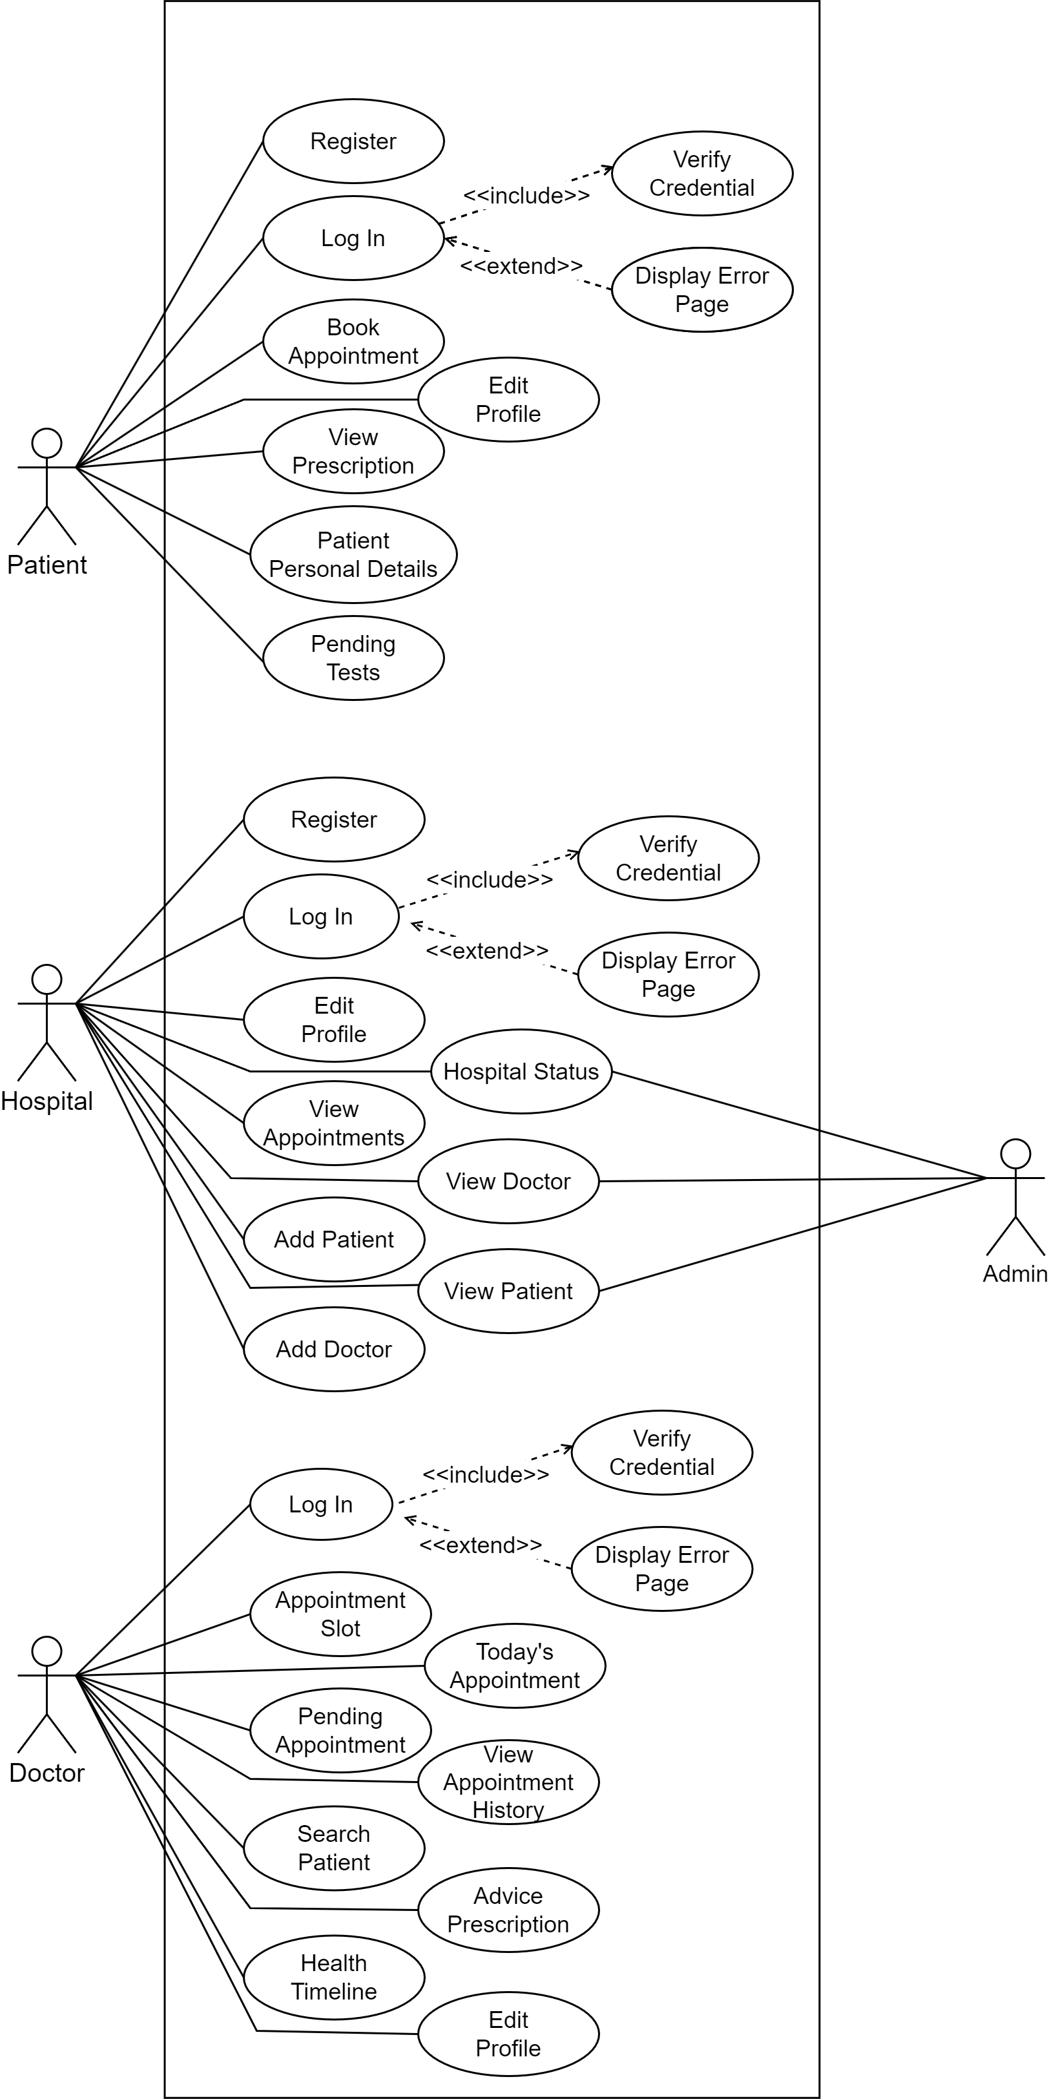
UML of Connect To Care
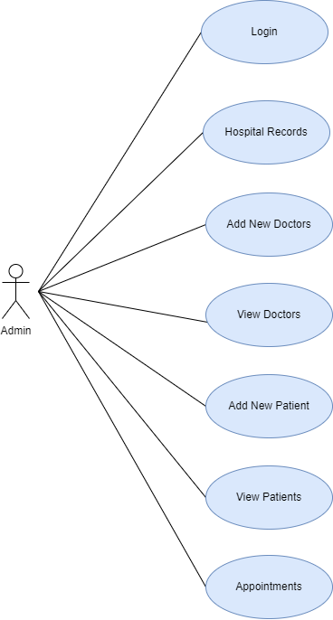
Hospital:

Fig. Use case diagram of Hospital Admin
  - In the Admin use case diagram Admin is the Actor.
  - Admin can handle following use cases:
    - Login
    - Hospital Records
    - View Doctor
    - Add New Doctor
    - Add New Patient
    - View Patients
    - Appointments
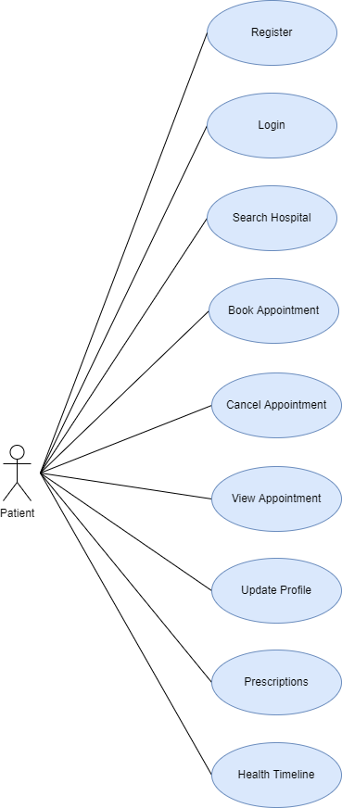
Patient:
Fig. Use case diagram of Patient

- In Patient use case diagram Patient is the Actor.
- Patient can handle following use cases:
- Register
- Login
- Search Hospital
- Book Appointment
- Cancel Appointment
- View Appointment
- Update Profile
- Prescriptions
- Health Timeline

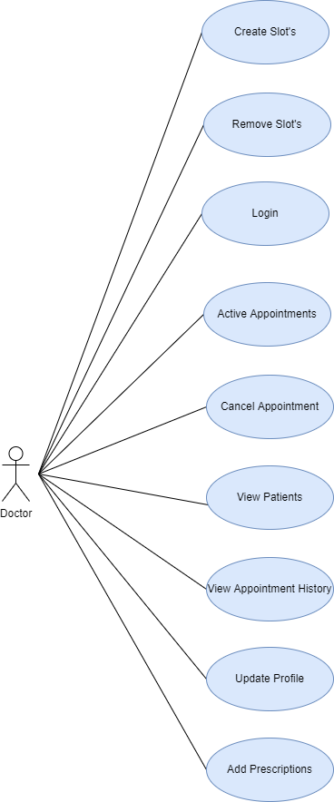
Doctor:

Fig. Use case diagram of Doctor
- In the Doctor use case diagram Doctor is the Actor.
- Doctor can handle following use cases:
  - Login
  - Create Slot’s
  - Remove Slot’s
  - Active Appointment
  - Cancel Appointment
  - View Patients
  - View Appointment History
  - Update Profile
  - Add Prescriptions

External Interface Requirements

User Interfaces
Connect To Care – Hospital Management System is basically is web application mainly works on the web browsers like Google chrome, Microsoft edge, etc. SO internet connection is also needed.
User interface is available on the browser by accessing the URL via HTTPS protocol user need to request for that URL so user can use Connect To Care web application efficiently.

Hardware interfaces

To use Connect To Care basic hardware requirements are as follows:
Minimum System requirement: 1 GB RAM, i3 or above processor

Non-functional Requirements

- Reliability:
The system should be available when requested for service by users: The system should work 24/7, it should always be up and running so that whenever the user wants to use it, it’s available.

- Performance:
- The system must have a good response time.
- The load time for the user interface should take less than two seconds.
- The log in information should be verified within five seconds.
- Queries shall return results within five seconds.
- The system should be able to achieve a lot in a specified amount of time.
- The system should be able to withstand a heavy workload.
- It should be able to respond to multiple numbers of people at the same time.
- The system must run error free while operating with a huge set of data.
- The system should be precise and accurate when dealing with data.
- The system’s error rate should be minimal.

- Security:
- All external communications between the system’s data server and clients must be encrypted:
- To ensure that the system is secure access to the various subsystems will be protected by a user log in screen and requires a user name and password.
- The access permissions for system data may only be changed by the system’s data administrator: The system’s administrator should be the only one with the authority to enable access to the system data.
- All system data must be backed up every 24 hours and the backup copies stored in a secure location which is not in the same building as the system: This is done to avoid loss of information in case of system crash. The system data should be stored in storage device e.g. hard drive, CD, Flash drive or it could be stored in files.

- Usability:
- The system should include well-structured user manuals.
- The system should have a well- structured easy to understand manual to guide its users.
- The system should have Informative error messages. o It should explain what the user did wrong.
- It should show where exactly the error can be found. o It should explain how to recover from the error.
- The error message should be simple to understand.
- The system should have a well-formed graphical user interface.
- The system should be user-friendly: The system must be easy to learn for both novices and users with experience from similar systems.
- The system must be efficient for the frequent user.
- The system must be easy to remember for the casual user.
- The user must understand what the system does.
- The user must feel satisfied with the system.

- Safety:
- The system should maintain a good backup: Maintaining backups ensures that the system’s database is secured, which means that in case of an emergency or accident the system can be easily restored.

- Maintainability:
- The system should be able to be transferred from one environment to another.
- The system should still work perfectly when it is transferred from one operating environment to another.
- It should run on Microsoft windows, Linux, UNIX, and Mac OS.
- The system should be easy to maintain.
- In other for the system to be easy to maintain it should be done with an object-oriented language which is easy to maintain.
- Maintenance of the system should be cost efficient.
- Maintenance of the system should be less frequent.
- The system should easily adapt to changes made.
- The system should be able to deal with additional international conventions such as languages, time zone, styles.
- The time zone should correspond to that of the user.
- The system should be able to be used on multiple platforms.
- The system should function properly on various platforms like hardware, browser, and virtual machine etc.

Other Requirements

Technical Requirement

Frontend: React 18.2.0
Backend: Sprint boot using java 8
Database Management System: MySQL 8.0.30

Database
MySQL 8 used

